

**Hessisches Staatstheater Wiesbaden**

**Technical Rider**

**Main Theatre Stage**

Last updated 05.05.2023

**Contact**

Hessisches Staatstheater Wiesbaden  
Christian-Zais-Str. 3  
65189 Wiesbaden

0611 132 1

**Brief description/ Stage area**

Platforms I-V are 17m wide and 3m deep all around the platform.

Platforms I-III are so-called double-decker platforms; max. lift 4.50m. The clear height inside (visible) is 3.60m, the clear width approx. 12.20m. The floating floor forms the stage floor here. Platforms I-III can only be lowered to -0.40m.

Platforms IV-V are not double-decker platforms, here only the deck moves, the platform floor stays fixed; max. lift 3.0 m. Platforms IV-V can be lowered 1.98 m.

→ The speeds for raising/lowering the platforms are computer-controlled; the noise of this movement can be clearly heard during ‘open’ movement within a scene.

All platforms are equipped with tilt adjusters; the platforms can be tilted to a total tilt of approx. 10% - however, the tilt adjusters are not integrated into the computer control system.

All platforms can be accessed from the side in the understage area.

It is not possible to visually conceal the platforms when they move up/down, the gap through which they move is too small - i.e. technically visible equipment must be accepted.

There is a drop trap system that can be moved under each platform; by opening the top sliders (‘flaps’, see floor plan), the drop trap can be moved between -2.90m and +/-0.0m.

The turntable of the revolving stage is integrated into the backstage carriage. It has a total area of

17.0m x 15.0m and an overall height of 0.40m, and can be lowered to +/-0.0m using all the platforms; not lower.

Using the tilted platforms and lowering the turntable at the same time is not possible.

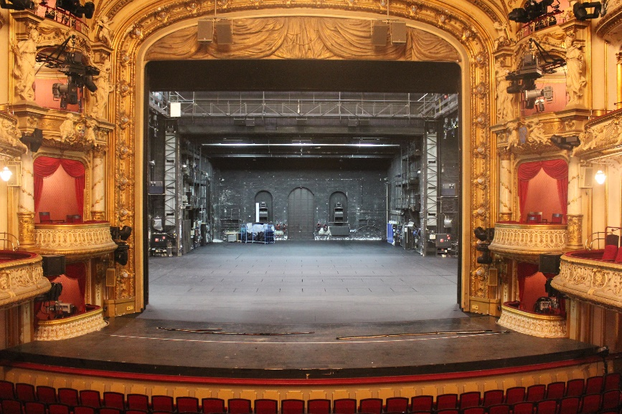

View of the proscenium arch from the auditorium

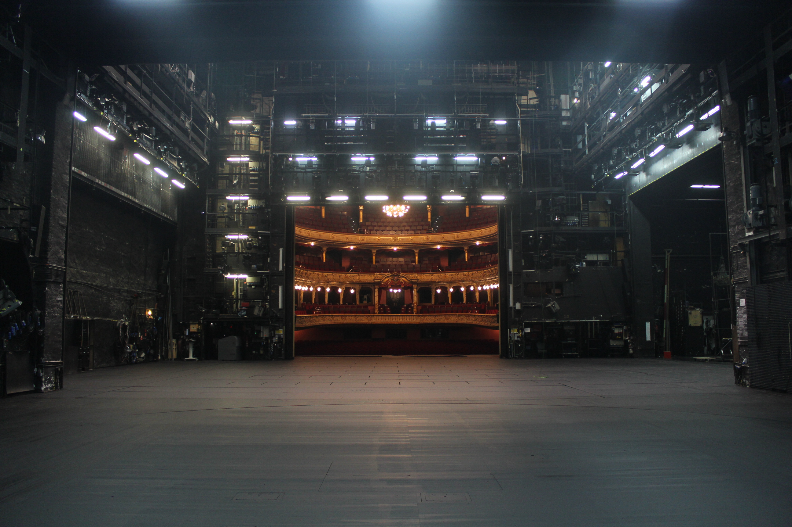

View into the auditorium from backstage

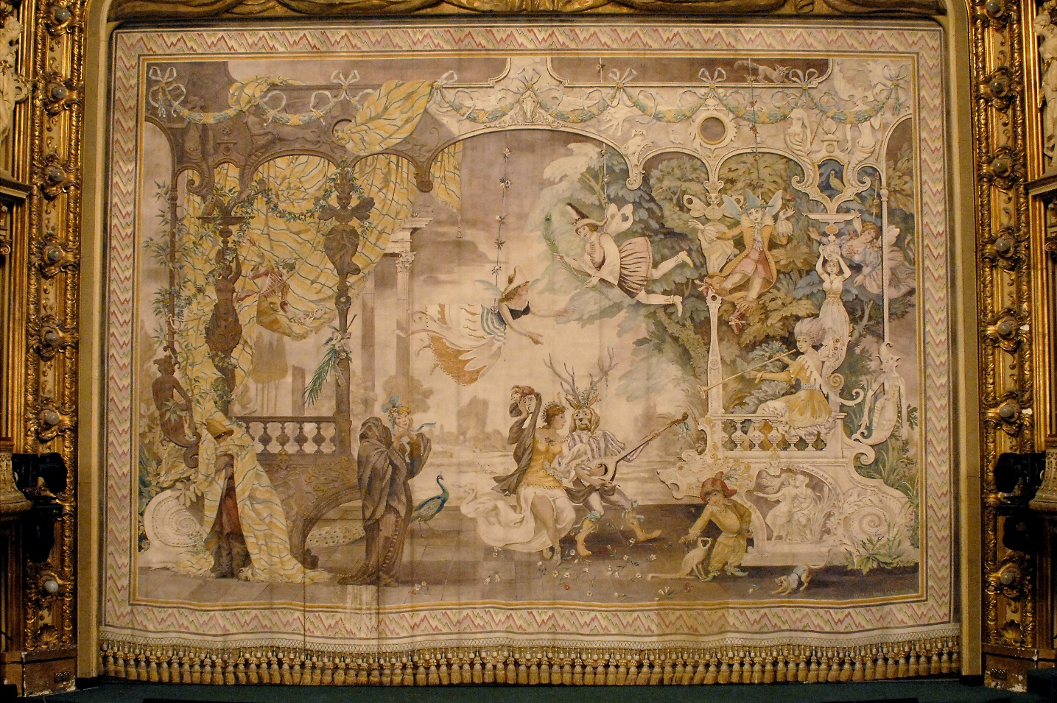

Iron curtain

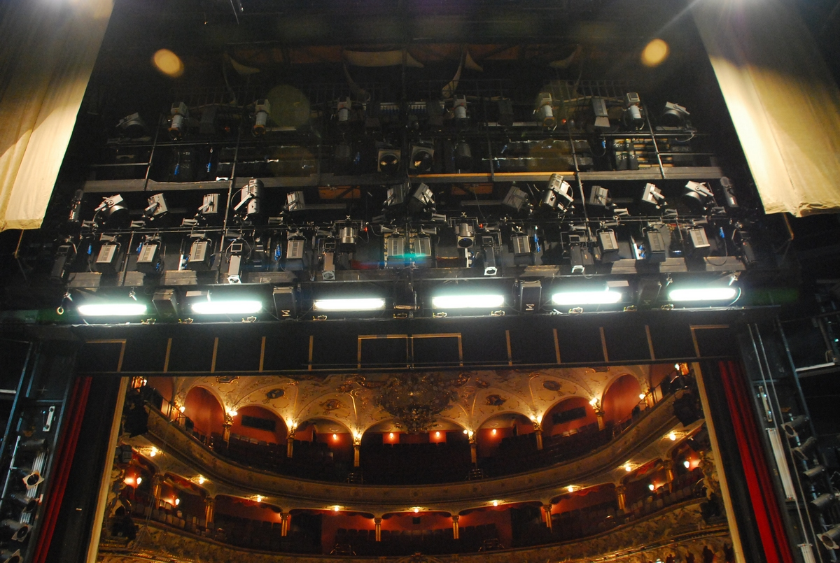

Proscenium bridge

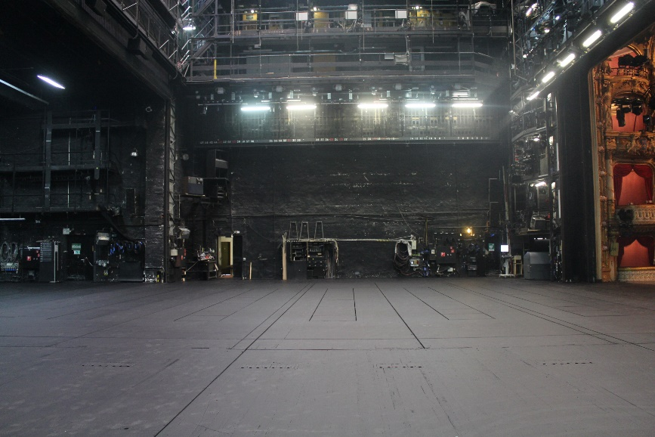  
View of the right side of the stage

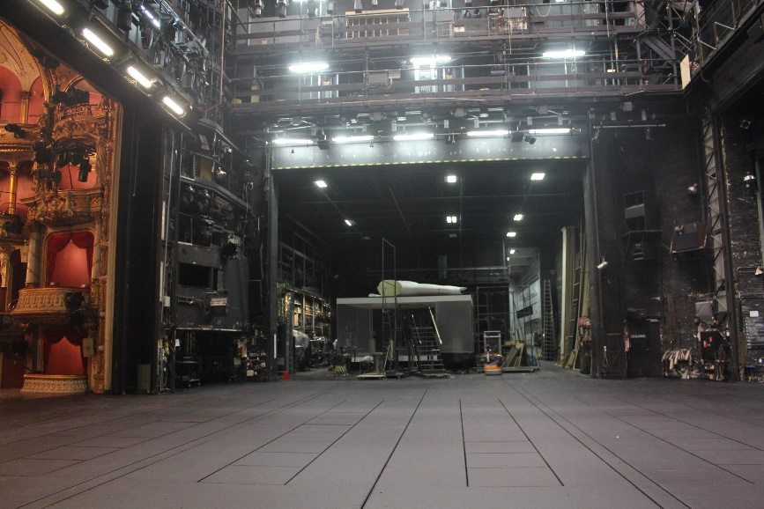

View of the left side of the stage

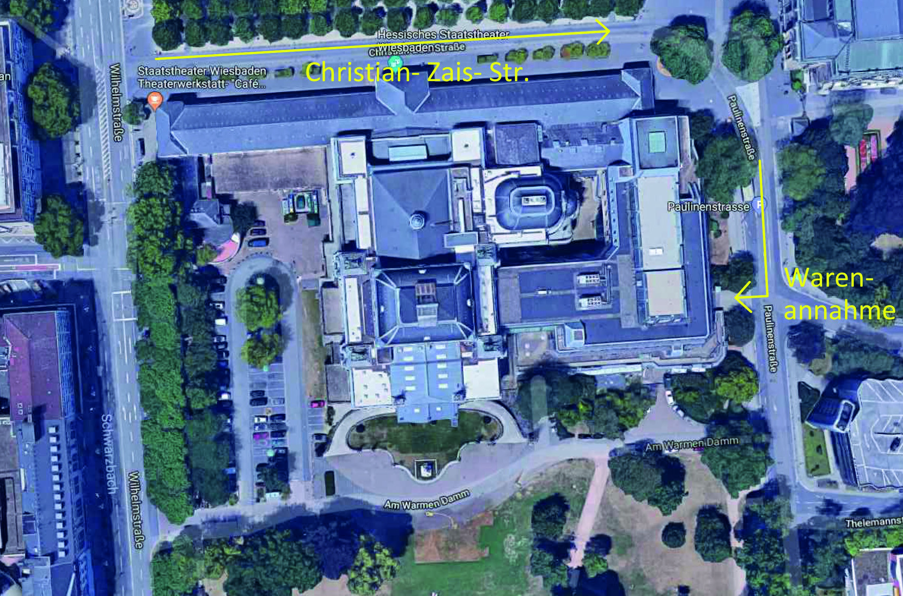

Delivery scenery etc. (goods receiving area, loading bay)

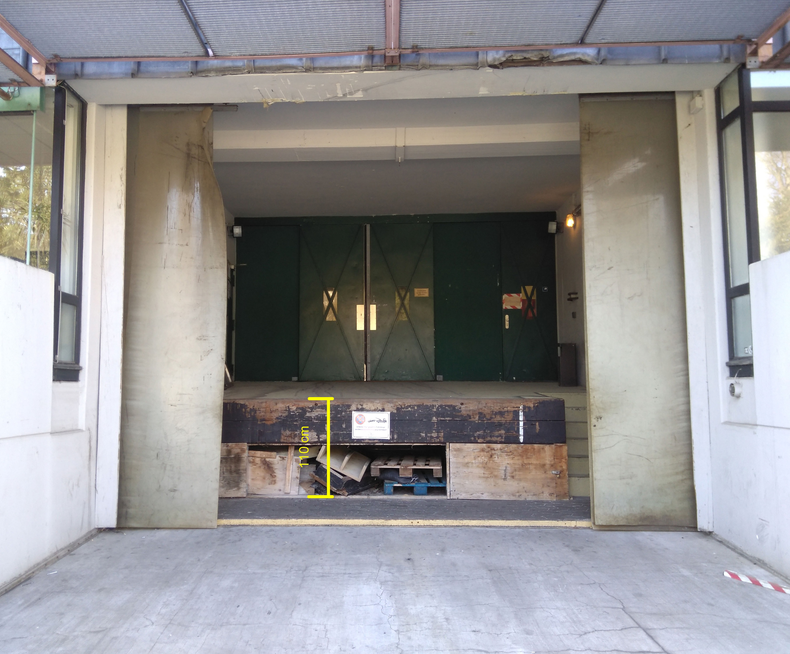

Loading bay

**1.1 Stage**

**1.1.1 Orchestra pit**

Parapet Height 0.93 m

Area Depth to the forestage 4.58 m

Width between the ends of the parapet 16.08 m

Width between the proscenium boxes 12.23 m

Width between the ends of the forestage 13.23 m

2 platforms Lift; individually adjustable speed 0 to – 2.50 m

Speed 0.20 m/s

Hoists 2 point hoists, can only be operated together;   
max. load 500 kg each

Please enquire about whether they can be used

**1.1.2 Proscenium**

Forestage Height 1.17 m

Area Depth from forestage to zero line 3.27 m

Depth from parapet to zero line 7.87 m

Width between the ends of the forestage 13.01 m

Width under safety curtain 11.50 m

Prompter’s box Width x depth 0.76 x 0.76 m²

(Zero line: rear edge of technical portal)

**1.1.3 Portal**

Dimensions Depth from front edge of safety curtain to zero line 1,28 m

Width under safety curtain 11.50 m

Width of technical portal 11.98 m

Height, adjustable + 3.30 bis + 8.40 m

Safety curtain/iron curtain with door; decorated with motifs on audience side

Width 13.00 m

Height 9.27 m

Thickness 0.20 m

Door; 2.50 m to left of centre; opens to stage right

Main curtain Red velvet; can open horizontally or vertically

Zero track Number of flybars 3

Length 13.00 m

Diameter 76 mm

Load capacity 650 kg each

Height 0.20 – 22.29 m

Speed, continuously adjustable 0 – 1.80 m/s

**1.1.4 Stage**

Area Width; inner panorama 17.81 m

Depth; technical portal to panorama (MH 47) 17.00 m

Height End position flyrods 2.65 m

End position overhead lights (without spotlights) 21.20 m

Height under 1st gallery 9.80 m

Backstage Through access; width x height 18.00 x 9.00 m

Sides of stage Through access; width x height 12.54 x 8.49 m

Platforms Double-decker platforms I - III max. 12 t -0.40 to +4.50 m

Platforms IV- V max. 12 t -1.90 bis +3.00 m

Tilt continuously adjustable max. 10 %

Lift speed continuously adjustable 0 to 0.12 m/s

Drop trap Can be moved under all platforms max. 2 t 10 m x 1 m

Lift speed 4 settings max. 0.12 m/s

Backstage carriage Overall height can be lowered 0.40 m

Turntable diameter 14.00 m

Rotating speed 0° to 360° ca. 60 s

Side stage carriages Area 2 units 17 m x 6 m

(out of order) Overall height can be lowered 0.20 m

**1.1.5 Overstage machinery**

|  |  |  |  |  |  |  |
| --- | --- | --- | --- | --- | --- | --- |
|  | Number | Ø | Length | Load capacity | Lift (m) | Lift speed |
| Mechanical hoists (MH) | 40 units | 76 mm | 17 m | 650 kg each | 0.20 - 22.65 | 0 – 1.80 m/s |
| Manual hoists (MANH) | 7 units | 76 mm | 17 m | 300 kg each | 0.20 - 22.65 | 0 – 1.80 m/s |
| Panorama hoists | 4 units | 76 mm | 15 m | 650 kg each | 0.20 - 22.65 | 0 – 1.80 m/s |
| (2 left, 2 right) |  |  |  |  |  |  |
| Point hoists | 46 units | / | / | 350 kg each | 0.20 - 22.65 | 0 – 1.80 m/s |
| Overhead lighting hoists | 5 units | 60 mm | 12 m | 600 kg each | 0.20 - 21.20 | 0 – 0.50 m/s |
| Gallery hoists | 10 units | 48 mm | 2.5m | 120 kg each | / | / |
| (5 left, 5 right) |  |  |  |  |  |  |

**1.2 Transport to and from the theatre**

Loading bay Height 1.08 m

Loading bay gate Narrowest and lowest point; width x height 2.05 x 2.80 m

Loading path Distance from storage to stage approx. 75 m

**1.3 Lighting**

**1.3.1 Lighting booth and back-up console**

The lighting control system consists of a Transtechnik Prisma NT + Booster (NTX) as the main console and a Transtechnik Prisma NT + Booster (NTX) as a backup console.

**1.3.2 Fixed positions**

**Auditorium:**

2x Robert Juliat D’artagnant 2.5kW HMI + Rainbow 8“

2x 2.5 kW Arri Fresnel lens HMI + H&G DarkVader 300 + H&G MagMax 300

15x JB-lighting P18 HC

6x JB-lighting P12 HC

2x 5kW Arri Fresnel halogen

2x 2kW ENI follow spots halogen + Rainbow 8“

1x PANI 6kW stage projector + zoom optics spot + Rainbow 12“ 6x Chauvet Ovation E-910C

2x ENI 1kW profile spots (conductor) 6x 2kW ENI zoom + Rainbow 8“

2x 2.5 kW Altmann follow spot HMI + H&G SH80 + Rainbow 8“ 2x 1.2kW Altmann zoom halogen

**Portal bridge:**

6x Mac Viper Performance

6x 2kW Strand Alto F

4x 1,2kW Altmann Zoom 2x 500W low-voltage follow spots 4x 2kW Strand Alto PC 6x 2kW ENI profile spots 26°

**Overstage lighting bridges (5):**

Each equipped with:

6x MacEncore LED wash (PC) warm 5x MacEncore LED Wash (PC) cold 6x 4flg fluorescent lights (RGB+Coolwhite)

**Portal towers left and right:**

Each equipped with:

2x MacEncore LED wash (PC) cold 1x JB-lighting P18 HC

1x 2,5 kW Arri Fresnel lens HMI + H&G DarkVader 300 + H&G MagMax 300 2x 2kW ADB PC

**Gallery left and right:**

Each equipped with:

6x 2kW Altmann zoom 6x 2kW ENI zoom

**Track/Aisle towers (10):**

Each equipped with:

4x 1,2kW Altmann zoom 2x 1kW PAR 64

**Track/Aisle towers (12):**

Each equipped with:

2x Robe Parfect 100 RGBW 4x 1kW PAR 64

**1.3.3 Mobile equipment**

**Number of devices**

8 2.5 kW Arri Fresnel lens HMI + H&G DarkVader 300 + H&G MagMax 300

12 MacViper performance 16bit

12 MacViper wash 16bit

10 Aisle towers/track stands

12 Partowers

4 ETC Fos4 Fluter

14 Startube RGBW

10 LDDE Slim FR1440

6 LDDE Nanopix 1200

16 Swoboda

**1.3.4. Colour scrollers**

**H&G Madmax 300:**

**Hagenbach & Grill MagMax 300**

Pos LEE Rosco % Set

1 117 66 0% 0

2 116 95 4% 10

3 161 367 8% 20

4 183 69 12% 30

5 HT181 / 16% 40

6 HT119 / 20% 51

7 HT197 / 24% 61

8 200 3220 30% 76

9 201 3202 36% 91

10 202 3204 40% 102

11 203 3208 44% 112

12 130 0 48% 122

13 152 304 52% 132

14 206 3409 56% 142

15 205 3408 60% 153

16 204 3407 64% 163

17 105 21 68% 173

18 106 26 72% 185

19 113 342 76% 193

20 101 312 82% 209

21 138 388 86% 219

22 242 93 90% 229

23 HT124 / 100% 255

**Hagenbach & Grill MagVader 350:**

**HB Arri**

**X**

**Pos LEE Rosco % Set**

1 130 0 0% 0

2 144 L144 10% 25

3 201 3202 25% 63

4 200 3220 40% 102

5 197 HT197 50% 127

6 HT119 / 65% 165

7 71 605 80% 204

8 242 93 100% 255

**Rainbow 8“ + 12“:**

**VB**

**Pos LEE Rosco** %  **Set**

1 HT124 / 0% 0

2 242 93 4% 10

3 138 388 8% 20

4 117 66 12% 30

5 140 72 16% 40

6 161 367 20% 51

7 132 68 25% 63

8 HT181 / 28% 71

9 HT119 / 34% 86

10 200 3220 36% 92

11 201 3202 41% 104

12 202 3204 44% 113

13 203 3208 50% 127

14 130 0 54% 135

15 152 304 58% 147

16 206 3409 61% 157

17 205 3408 65% 166

18 204 3407 70% 178

19 105 21 74% 188

20 147 317 78% 199

21 101 312 83% 212

22 164 25 87% 223

23 106 26 91% 232

24 113 342 94% 241

25 136 52 100% 255

**1.3.5 Distributors and electrical connections in the stage area**

Left side 1x 125A CEE direct

6x 32A CEE direct

16x 32A dimmable

40x 10A dimmable

2x 16A switchable

Right side 1x 125A CEE

6x 32A CEE

16x 32A dimmable

40x 10A dimmable

2x 16A switchable

Portal tower left 16x 32A dimmable

2x 32A CEE direct

8x 16A switchable

Portal tower right 16x 32A dimmable

2x 32A CEE direct

8x 16A switchable

Turntable 6x 32A dimmable or direct

Backstage 2x 125A CEE direct

12x 32A dimmable

12x 10A dimmable

2x 32A CEE switchable

2x 16A 1pol switchable

Wings left 1x 32A 1pol direct

6x 16A dimmable

1x 32A dimmable

Wings right 1x 32A 1pol direct

6x 16A dimmable

1x 32A dimmable

Dome 6x 32A dimmable

1x 32A CEE direct

1x 16A switchable

Upper circle 30x 32A dimmable

2x 32A CEE direct

4x 16A switchable

Middle circle 8x 32A dimmable

2x 32A CEE direct

4x 16A switchable

Dress circle 10x 32A dimmable

2x 32A CEE switchable

4x 16A switchable

Stalls 6x 32A dimmable

2x 32A CEE direct

1x 16A switchable

**1.4 Sound**

**1.4.1 Auditorium mixing desk**

Mixer Stagetec Aurus Platinum

Yamaha CL-5 Yamaha CL-1 Yamaha QL-1

Audio network Yamaha Dante

Stagetec Nexus, Starrouter

Periphery Sound systems: SCS, Q-Lab

Abletonlive

DAWs: Steinberg wavelab, Steinberg Nuendo Waves soundgrid

**1.4.2** Sound control desk, behind glass

Mixer Stagetec Aurus Platinum

Periphery see above periphery “auditorium mixing desk”

**1.4.3** Distributor box structure

Stage and auditorium approx. 30 mic, line, video, LSP, listening channels 230 V light signals

4x network connections

Control console Stagetec Nexus (digital audio router)

Ghielmetti (analogue audio router) Dante network

**1.4.4 Sound system**

Portal Meyer Sound

Galileo

Stage Kling+Freitag

Syrincs

Mobile systems 3x Yamaha Rio

Mikroport (sound system made by Sennheiser) 10x transmission distance

2x In-ear Sennheiser various speakers mixer consoles (small)

100 Volt 62 amplifier channels on the stage and in the auditorium

**1.5 Video**

**Front projection**

Panasonic DZ21K, 20000 lumen, 1920 x 1200 pixel, light + 3 DLP-chip

**Back projection**

Eiki LC-XT5, 15000 lumen, 1024 x 768 pixel, light + LCD TFT panel

**PC**

Mac Pro, 32GB, NVIDIA Quadro K5000, OS X El Capitan

**Software**

Projection control with QLab 4

Laptop for mobile use with QLab 3

**Cameras** (used in both the small and the main stages)

Panasonic HDC-SD80 Camcorder

Panasonic NV-GS140 Camcorder

Panasonic NV-GS230 Camcorder

Sony DCR-VX2000 large camcorder

Sony PMW-100 large camcorder

**1.6 Props**

**1.6.1 Fog machines** (used in both the small and main stages)

**Ground fog machines**

Number

Cyro Fog 2

Antari 1

**Hazers**

Unique 4

MDG 1

**Fog machines**

Viper 2.6 6

Viper NT 2

Viper S 3

Power Tiny 4

Tiny S 2