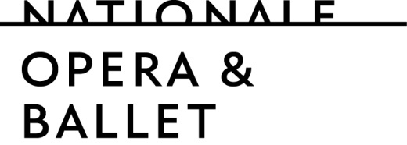

With around 75 dancers in the main company and 12 dancers in the Junior Company, Dutch National Ballet (HNB) performs a wide repertoire of classical, modern and new ballet pieces. Together with Dutch National Opera, HNB is part of Dutch National Opera & Ballet. Both companies are among the top institutes in their fields, both nationally and internationally. This high level is partly achieved because everything for the performances, from wigs to large set pieces, is made in our own workshops. All in all, we are with around 600 employees.

Dutch National Ballet is looking for an experienced

BALLETPIANIST - ACCOMPANIST
full-time

to accompany class, rehearsals and performances.

The function
As a pianist of Dutch National Ballet you are accompanying ballet classes, workshops, studio rehearsals and occasionally performances. You work for the main company and for the Junior Company. You may also be asked to work during special events like auditions and presentations. Where necessary you will arrange existing repertoire for piano rehearsals.

In daily practice the pianist has a relationship with the balletmasters with whom he/she works with and also with other members of the music staff. He/she stands hierarchically under the Music Director of Dutch National Ballet.
Job requirements
We are seeking someone with a classical piano degree from a music conservatory who has at least five years of experience as a pianist of a ballet company. An ability to improvise within the classical music idiom is essential. The variety of repertoire, activities and schedules also call for someone who is flexible and has the capacity to accommodate a broad spectrum of different artistic aesthetics.

Our offer
We initially offer a contract for the duration of 12 months. Depending on age and experience, the salary is a minimum of € 2.599,00 and a maximum of € 3.644,00 gross per month for full-time employment. This amount excludes 8% holiday pay and a year-end bonus of € 400.

Audition
An audition will be part of the selection procedure.

Deadline
Applicants can submit their letter of interest and resume up to February 10, 2020 via
https://werk.operaballet.nl/vacaturebank/balletpianist
If you have a film recording available of a class or rehearsal you have accompanied, we want to ask you to add a link to this recording in your letter of interest or upload a movie file.

Information and reactions
For further information you can contact Matthew Rowe, Music Director of Dutch National Ballet by phone: + 31 (0)20 551 8852 or by e-mail: m.rowe@operaballet.nl.

Dutch National Opera & Ballet strives to be a reflection of society. For that reason we strongly invite candidates with a non-Dutch cultural background to react on this vacancy.

