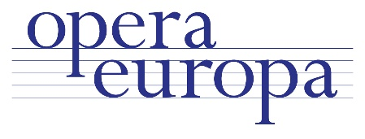
Joint Technical & Production and Costume, Make-up and Wig forum
Vilnius, 27-29 February 2020

Programme

Thursday 27 February

15.30 | Registration opens
16.00 | Vilnius team demo – Baroque woollen wigs and Restoring costumes over time
17.15 | CMWTP Ice breaker / How hard can it be? Soren Larsen (Copenhagen) and Timo Tuovila (Helsinki)
18.30 | end
19.30 | Dinner

Friday 28 February

9.00 | Registration opens
9.30 | CMWTP Welcome
10.00 | CMWTP Case study : Turandot co-production  with presentations from Madrid, Vilnius, Toronto
11.30 | Coffee break
12.00 | CMWTP Ask Me Anything - Top Hazards in Health and Safety  with Dominique Perrissin-Fabert, Health and Safety Manager (London ROH)
13.00 | Lunch
14.00 | CMWTP Co-productions survival handbook  discussion led by Robby Duiveman (Amsterdam) and David Stuttard (Wexford)
15.30 | Coffee break
16.00 | C Measurement taking | MW Measurement taking | TP Production data documentation for travel  Arturas Aslenskas (Vilnius), Bob Brandsen (London ROH)
17.30 | end
18.30 | Turandot  Directed by Bob Wilson end 22.30

Saturday 29 February

09.30 | CMW Guided tour of the workshops |  | TP State of the Union: discussion on current issues  Led by Charmaine Goodchild (Brussels)
10.30 | Coffee break
11.00 | CMWTP New Opera Europa tools: Operabook and new website  Led by Aline Chif and Audrey Jungers
11.45 | CMWTP Production and costume databases: Dièse / Multilingual dictionary  Led by Dièse users (Lyon, Stuttgart and ROH) and Julie Hoeffel (Strasbourg)
12.30 | Lunch
13.30 | C Costume Show & tell moderated by Markus Maas | MW Make-up & Wigs show & tell moderated by Jorg Muller |  | TP Technical guided tour
15.15 | Coffee Break
15.45 | CMWTP Second lives of costumes and sets – Round table discussion  Led by Małgorzata Szabłowska (Warsaw) and Carol Lingwood (London NT)
17.00 | Conclusions and next meetings
18.00 | End

If you have any questions, please contact Aline aline@opera-europa.org or call me on +32 486 69 03 79

